Knowledge Check W02 Part 1

Question 1

0.5/0.5 point (graded)

Which three fields are available when creating a Pie chart for visualization?

Legend

Group

Details

Values

Question 2

0.5/0.5 point (graded)

Consider the following chart: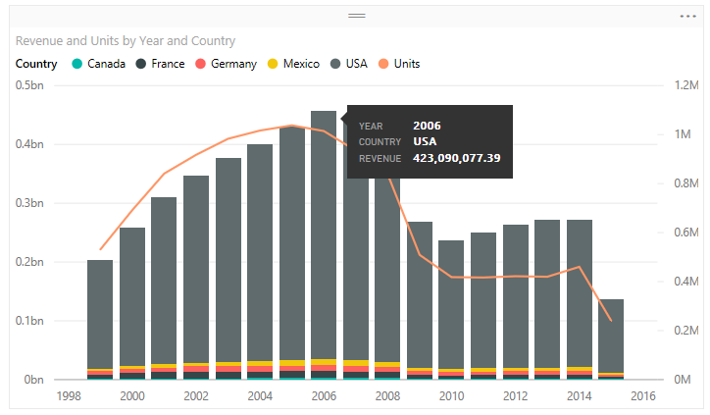Drag and drop the fields to the corresponding settings to create the above chart.

|  |
| --- |
| Shared Axis |
|  |
| Column Series |
|  |
| Column Values |
|  |
| Line Values |
|  |

Question 3

0.5/0.5 point (graded)

By default, which level of filter behaves the same as a slicer in a report in Power BI Desktop

Visual level filter

Page level filter

Report (All pages) level filter

Query level filter

Question 4

0.5/0.5 point (graded)

Consider the following chart:

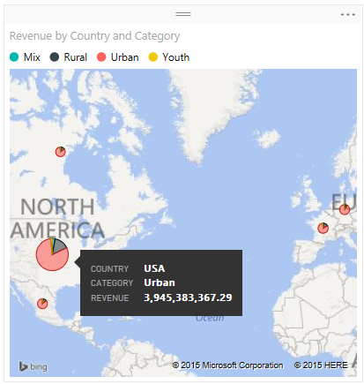

Drag and drop the fields to the corresponding settings to create the above chart.

|  |
| --- |
| Location |
|  |
| Legend |
|  |
| Longitude |
|  |
| Latitude |
|  |
| Size |
|  |
| Tooltips |
|  |

Question 5

0.5/0.5 point (graded)

Consider the following chart:

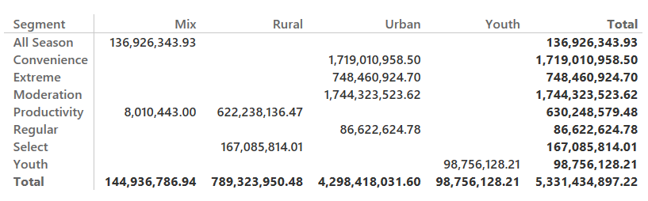

Drag and drop the fields to the corresponding settings to create the above chart.

|  |
| --- |
| Rows |
|  |
| Columns |
|  |
| Values |
|  |

Question 6

0.5/0.5 point (graded)

When creating a waterfall chart, which two field options that you need to define?

Category

Values

Y Axis

Size